Academy of Py Trends

One trend that has a large effect on overall passing rate is whether the school is a charter school or a district school. The overall percent of students with passing scores in charter schools is around 95.1% while the overall percent of students with passing scores in district schools is around 73.6%. The top five performing schools in the district are all charter schools while the five worst performing schools are all district schools shown in the two figures below.

Fig 1. Top Five Performing Schools based on overall passing rate percent

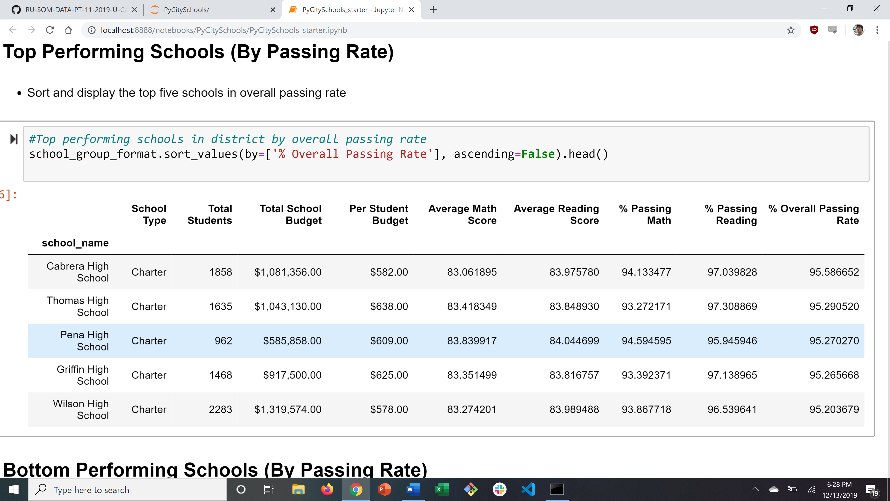

Fig. 2 Worst Performing Schools based on overall passing rate percent

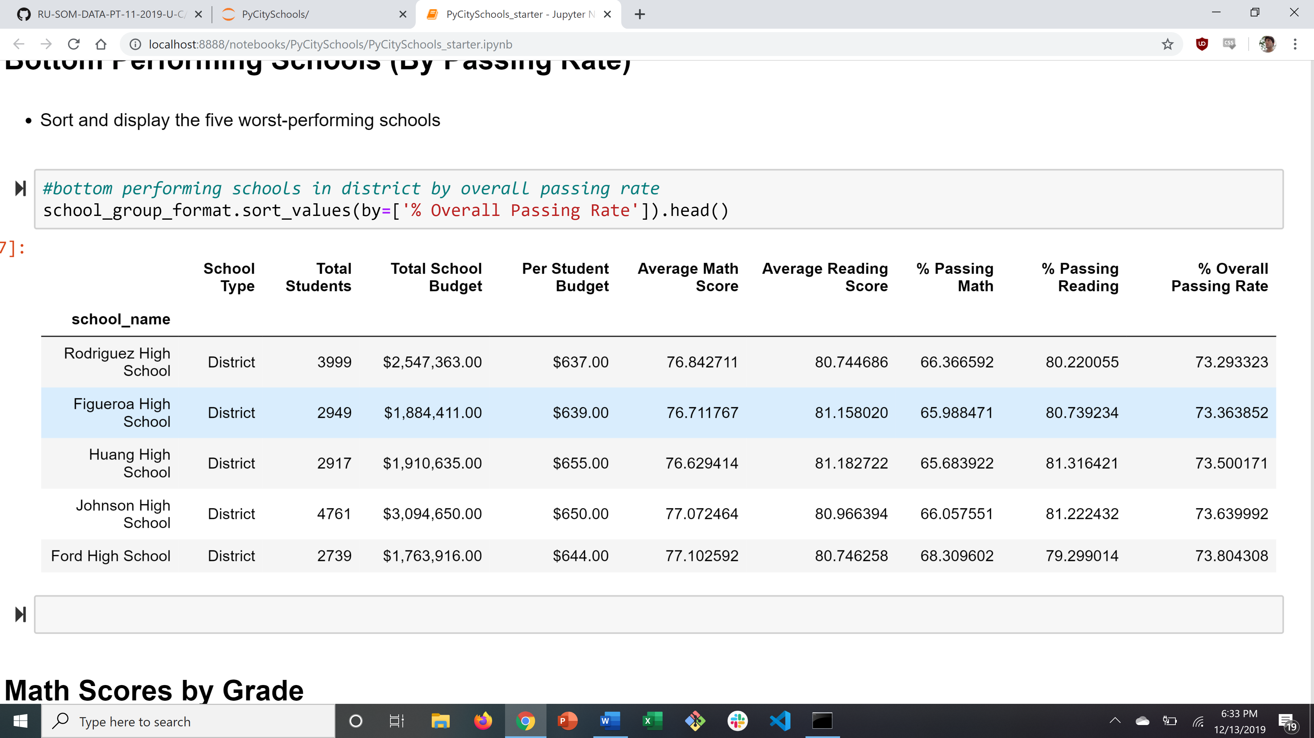

Also shown in the two figures above is that charter schools on average have less students than district schools. Which leads to the next impact on the percent of students receiving a passing score which is the total students attending the school. Schools with less students tend to have better test scores than schools with more students. Schools with less than 2000 students perform better than schools that had more, shown below.

Fig. 3 Test scores based on total students attending a school

